Worksheet 7– MM2EMD Transistors

Q1. Draw a diagram of a relay and explain how it works.

Q2. Why can't we supply large voltages and currents form microchips?

Q3. Draw a circuit diagram for a circuit that would use a small voltage/current signal to turn on a 20 V light bulb using an npn bipolar junction transistor.

Q4. What are the advantages/disadvantages of bipolar junction transistors.

Q5. What are the advantages/disadvantages of using a MOSFET? Why would you use a push pull pair to drive a MOSFET?

Q6. Draw a circuit diagram showing how a push-pull pair would be used to drive a MOSFET and describe what the advantages of using a push pull pair to drive a MOSFET are. Explain how a push-pull circuit works.

Answers

Q1. .
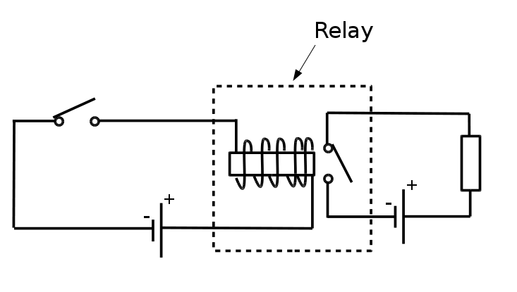
See notes of explanation.

Q2. Because they are only designed to supply 5V/25mA max. If you look inside a typical chip the bond wires are thinner than a human hair and would burn at high currents/voltages.

Q3.
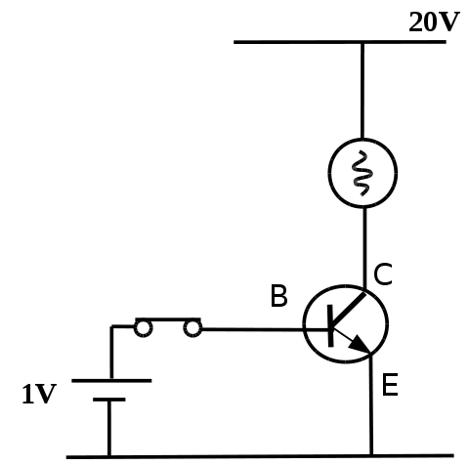
Q4. BJTs are very fast at responding to a changing base voltage/current. However, there is a 0.6 V drop between collector and emitter (just like a diode) – this means they are no good for high current applications as you would get lots heat dissipated on the transistor it's self. P_{diode}=I*0.6V

Q5. MOSFETs are good for high power applications because there is no 0.6 V drop across them, when turned on. Thus there is little power loss in the transistor when passing a high current. Any power loss in the MOSFET will be due to it's intrinsic resistance, which is low. The disadvantage of using a MOSFET is that it has a capacitive gate, meaning it takes a lot of current to turn on and off. Most chips will find it difficult to supply a high current to turn a MOSFET on/off quickly.

Q6.
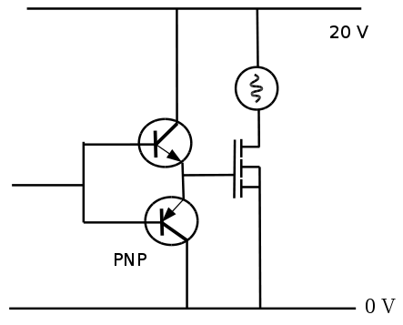
The advantage of using a push pull pair to drive a MOSFET is that current is not taken from the chip to charge/discharge the MOSFET gate, rather it is taken directly from the power rail. This enables the MOSFET to turn on and off fast. For explanation see notes.

