Worksheet 2 – MM2EMD Digital electronics

Q1. Draw the truth table of the following circuit
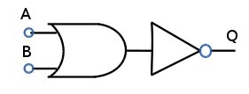
Q2. Draw the truth table of the following circuit
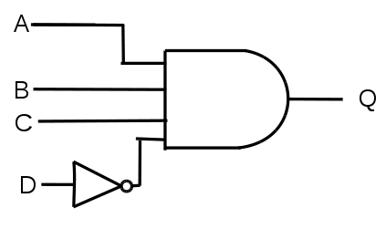
Q3. Draw the truth table of the following circuit
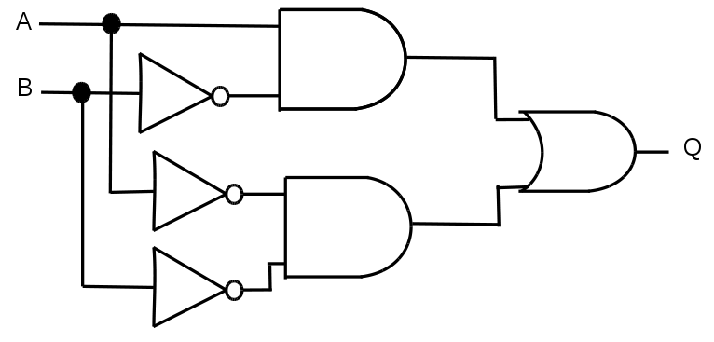
Q4. Draw the truth table of the following circuit
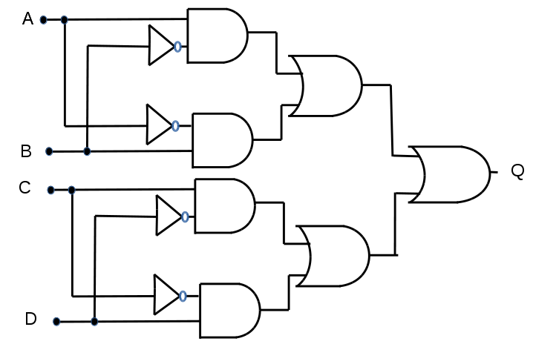
Hint – if you know the truth table of an XOR gate you can get to the answer quicker.

Q5. Draw the truth table of a JK flip-flop.

Q6. Explain in words why it is impractical to use use a simple OR gate with a feedback loop as a latch.

Q7. Draw a shift register. And name one application of this type of circuit.

Roderick MacKenzie 16/02/15

Q1.

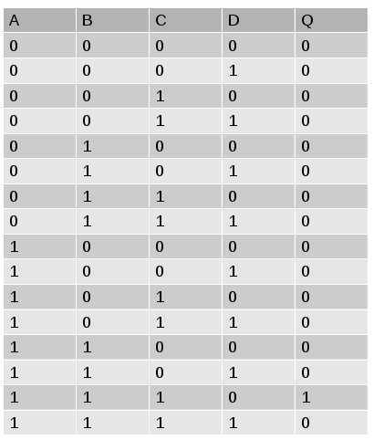
Q2.

Q3.


Q4.
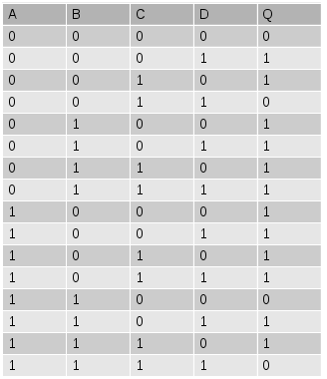
Q5.
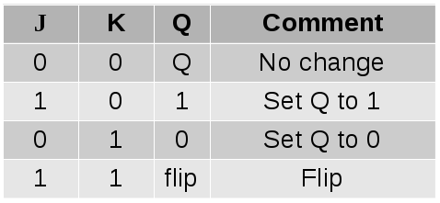
Q6. You can't reset a latch made of a single OR gate.

Q7.See lecture notes. An example of use is in a serial to parallel converter.

